# Iteration Two

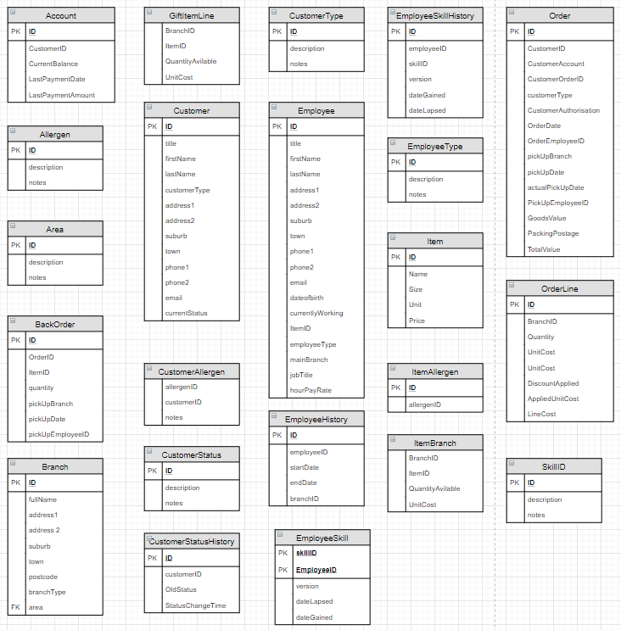Iteration Two:

This is an iteration of all the current tables that I believe will be used within the Database. This was made after Rob Oliver had talked to the class about the Assignment and had said "These are baseline tables, not all the information may be here, and you will need to think of more entries"

The talk had led me to think about the Database from an almost Management perspective instead of a Cash Register Operator perspective. A lot more entries were generated from the perspective change as well as more tables were made. Some of the tables seen here are what I am calling Dictionary Tables, such as SkillID, and these tables are just holding information to be called. Some tables are what I am calling Uniformers in which Table A and Table B flow into Table C so Table D can communicate with that instead. There is tables like ItemAllergen which may seem like unrequired step actually is for the Gift Boxes, instead of displaying [Item][allergen] one row at a time it will display [items][allergens] in one large row.

Tables have also been split and split again. I originally had a EmployeeSkills table that had everything about the employee's skill inside of it. I thought of breaking this down into its Skill and History table. Same can be applied to the Customers Account.

EmployeeType is a table made to say what type of employee they are i.e part time, full time, casual etc

EmployeeHistory is a table for if the employee has worked in another branch and how long they worked there - might add a time entry if the StartDate and EndDate is just 1 day

I had asked my father about the different payment types he gets from where he works made me make a CustomerType in which displays how they pay i.e cash, eftpos, tab [all payments are made on x month or by x time], account, "Laybuy"